Datasheet
M5 抗V5标签鼠单克隆抗体（HRP标记）

Product Unit Cat.#
M5 抗V5标签鼠单克隆抗体 20μl MF576-T
M5 抗V5标签鼠单克隆抗体 100μl MF576-01

【Storage】:Shipped at 4°C. Store at -20°C. Stable for 12 months at -20°C.

【Storage Buffer】: Solution in 0.01 M phosphate buffered saline, pH 7.4, containing 15 mM sodium azide.

【Background】: The V5 epitope tag is derived from a small epitope (Pk) present on the P and V proteins of the paramyxovirus of simian virus 5 (SV5). The V5 tag is usually used with all 14 amino acids (GKPIPNPLLGLDST), although it has also been used with a shorter 9 amino acid sequence (IPNPLLGLD)。本抗体为抗V5标签鼠单克隆抗体，可用于检测V5-Tag融合蛋白。本产品需使用二抗，用相应酶底物显色或化学发光法检测目的蛋白。

【Immunogen】: 人工合成多肽(GKPIPNPLLGLDST)
.
【Concentration】: 1 mg/ml.

【Reactivity】: The V5 tag antibody can recognize V5 tag fusion proteins.

【Applications】: Suitable for: WB ELISA.

【Isotype】: 亲和纯化鼠单克隆抗体IgG

【Purity】: Immunogen affinity purified

【Clone number】: Monoclonal

【Recommended Dilutions】
Western blot: 1:1000-5000.
ELISA: 1:500-1000

为了获得实验最佳效果，请根据实验调整最佳工作稀释度。

【Application Data】
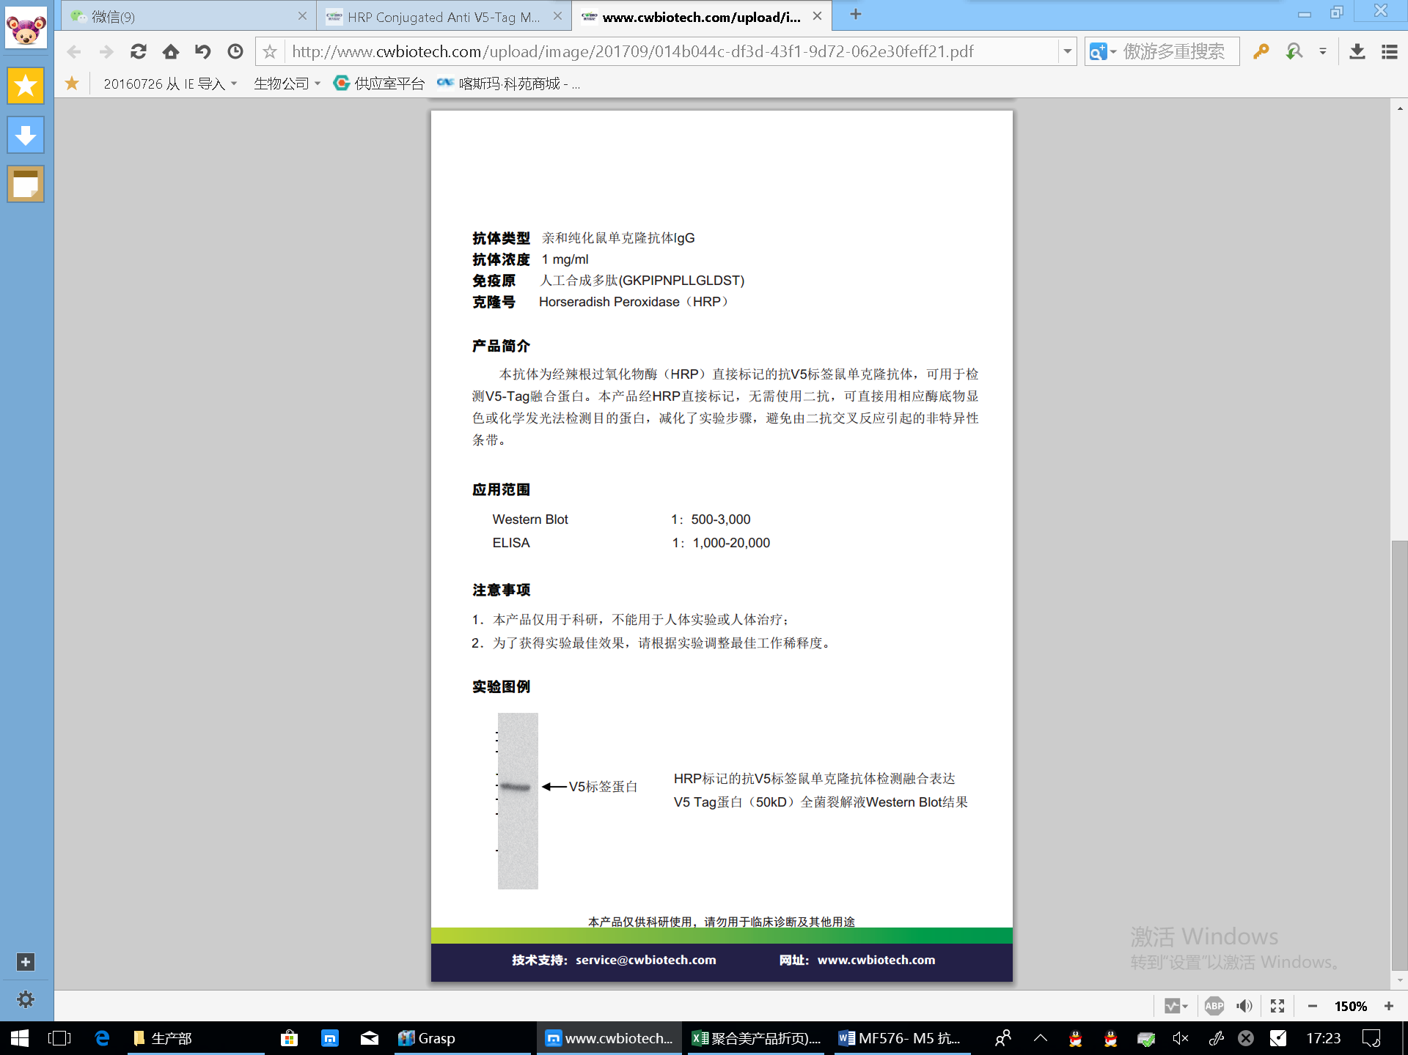

Please note: All products are "FOR RESEARCH USE ONLY AND ARE NOT INTENDED FOR DIAGNOSTIC OR THERAPEUTIC USE"

